Step1. Creating a S3 bucket with following name and folder and shown and uploading the CSV file into it.   
  
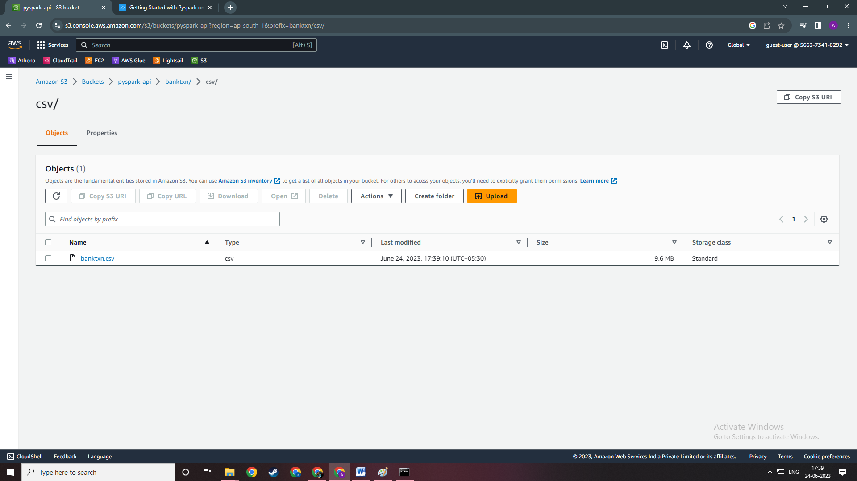

Step 2 . Setting up IAM Role

# For EMR_EC2_DefaultRole. Make sure in this Default role you add the policy as shown

# 

# For EMR_DefaultRole

For these role make sure you have This same policy attached to the role which are shown below

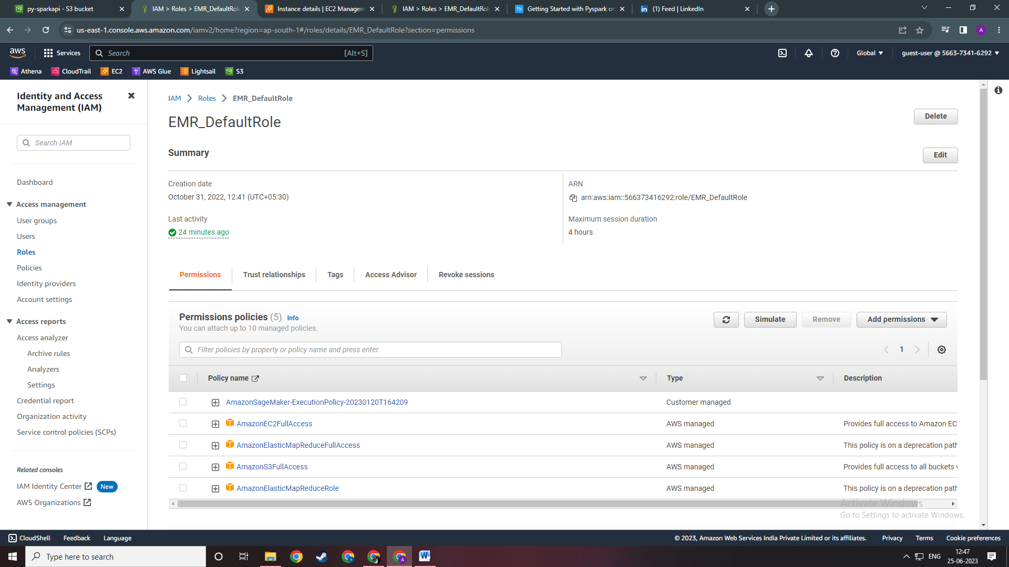

Step 3.

While Creating EMR cluster make sure you select the same Key pair as your EC2 instance and select the same Default role as shown in picture below

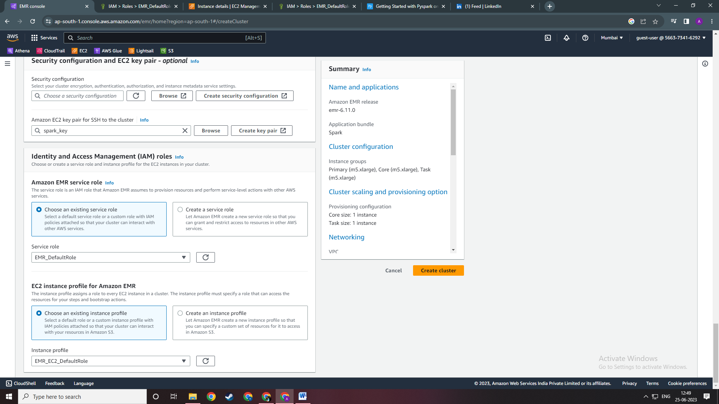

After that Create a AWS EMR cluster with the same key pair and Default role for EMR and EC2   
Config is shown below

